Project documentation

FitBuddy – AI Fitness Plan Generator using Gemini Models

Team ID : SWTID-2026-4146
Team Size : 5

Team Leader : Akkenapally Ramya
EMAIL: ramyaaramyaa.7002@gmail.com

Team member : Subhiksha K
EMAIL: subigayu379@gmail.com

Team member : Srimathi G R
EMAIL: srimathigr03@gmail.com

Team member : Pavithra M
EMAIL: ushamurugesan662@gmail.com

Team member : Gopika S
EMAIL: gopikasaravanan143@gmail.com

FitBuddy – AI Fitness Plan Generator using Gemini Models

Project Description:
FitBuddy is a web-based fitness application that uses Artificial Intelligence to create personalized workout schedules and nutrition guidance. The plans are designed according to the user's fitness objectives, such as losing weight, building muscles, or maintaining overall health.
The application is developed using FastAPI and integrated with Google Gemini AI models. It helps users easily create organized and suitable fitness routines with the help of AI.
Users can enter details such as name, age, weight, fitness goal, and preferred workout intensity. Based on these details, FitBuddy generates a customized 7-day workout plan. Users can also give feedback about their current plan, and the AI can modify the plan according to their changing requirements. It also provides useful nutrition or recovery suggestions based on the selected fitness goal.
FitBuddy uses SQLite to store user information and generated fitness plans. The application provides both API services and an interactive HTML interface, making it simple and convenient for users to access their fitness plans.

Scenarios:

Scenario 1

A user enters personal information such as name, age, weight, fitness objective (for example, “weight loss” or “muscle gain”), and preferred workout intensity (“high,” “medium,” or “low”). Based on these details, the system creates a customized 7-day workout schedule. Each day’s exercises are selected according to the user’s fitness goal and experience level, providing a structured and personalized training routine.

Scenario 2

A user provides feedback about their current workout plan, such as requesting “more cardio” or “additional rest days.” The system analyzes the feedback and generates a revised workout plan according to the user’s updated preferences. This allows the workout routine to adapt as the user’s requirements, preferences, and progress change.

Scenario 3

A user asks for a nutrition or recovery recommendation related to their chosen fitness goal. The platform provides a short and useful suggestion, such as including protein in a post-workout meal for a muscle-building goal. These recommendations support the user’s training routine by connecting exercise with appropriate nutrition and recovery practices.

Scenario 4

An admin or coach logs into the platform and accesses a dashboard containing registered user information and their workout plans. The dashboard helps them monitor user activity, review individual plans, and compare previous plans with updated versions. This makes it easier for trainers to manage and monitor multiple users efficiently.

Technical Architecture:
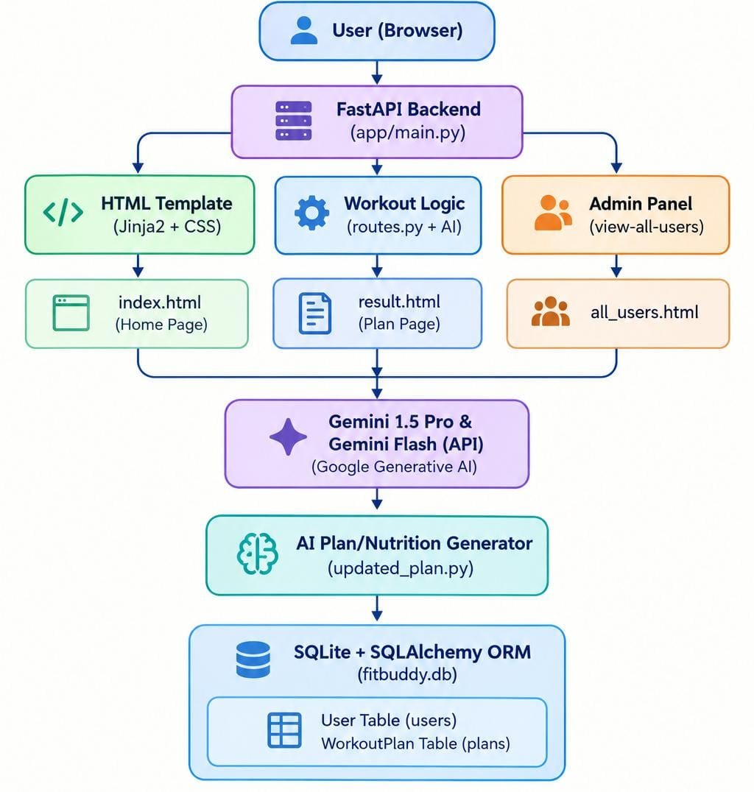

Pre - requisites:
- FastAPI Framework Knowledge: FastAPI Documentation
- Gemini API Familiarity: Google Generative AI Documentation
- HTML, CSS, and Jinja2 Template Skills: W3Schools HTML/CSS/Jinja2 Tutorials
- Python Programming Proficiency: Python Official Docs
- Version Control with Git: Git Documentation
- SQLAlchemy and SQLite Basics: : SQLAlchemy Docs
- Environment Setup (pip, virtualenv, or conda): Virtualenv Guide
- Uvicorn ASGI Server: Uvicorn Docs

Project Workflow:

Milestone 1. Model selection and Architecture
Activity 1.1. Research and Select the Appropriate Generative AI Model
Activity 1.2. Define the architecture of the application
Activity 1.3. Set up the development Environment

Milestone 2. Core functionalities Development
Activity 2.1. Develop the core functionalities
Activity 2.2. Implement the FastAPI Backend to Manage Routing and User Input Processing

Milestone 3. route.py Development
Activity 3.1. Writing the Main Application Logic in routes.py

Milestone 4. Frontend Development
Activity 4.1. Designing and Developing User Interface
Activity 4.2. Creating Dynamic Templates with FastAPI’s Jinja2

Milestone 5. Deployment
Activity 5.1. Preparing the Application for Local Deployment
Activity 5.2. Testing and Verifying Local Deployment

Milestone 1. Model selection and Architecture
This milestone involves identifying and choosing the most suitable generative AI model from Google’s Gemini series for the FitBuddy application. Different Gemini models are reviewed based on their features, performance, and capabilities to determine which one best supports the application’s main requirements, including creating personalized workout schedules, modifying plans according to user feedback, and offering customized nutrition and recovery recommendations.
Activity 1.1: Research and Select the Appropriate Generative AI Model
Understand the Project Requirements
FitBuddy’s AI model was required to:
- Create structured 7-day workout plans
- Offer concise and practical nutrition tips
- Modify workout plans based on user feedback
- Perform efficiently in real-time, web-based interaction
Model Evaluation
We initially tested several Hugging Face models:
- T5 & BART – For generating workout and nutrition content
- DistilBERT – For possible intent classification
- Bloom – For general-purpose text generation
Although these models performed well in basic text generation, they had some significant limitations.
These models required:
- Hosting through Hugging Face or a local GPU setup
- Fine-tuning or detailed prompting to create structured plans

Final Model Selection
After comparing the models, we selected Google Gemini models for production:
- Gemini 1.5 Pro
→ Used to generate structured 7-day workout plans and update existing plans
→ Provides detailed, context-aware, and consistently formatted responses
- Gemini Flash
→ Used to generate quick and practical nutrition tips
→ Lightweight and efficient for fast API requests
Reasons for Choosing Gemini:
- API-based and easy to integrate with FastAPI
- Naturally handles structured formats such as days and sections
- Provides high accuracy with minimal prompt adjustments
- Fast and scalable for feedback-based plan revisions

Activity 1.2.Define the architecture of the application
Architecture Overview: FitBuddy uses a modular FastAPI-based architecture
- Frontend: HTML + Jinja2 templates for receiving user input and presenting the output
- Backend: FastAPI for handling routes and managing application logic
- AI Layer: Google Gemini APIs (Pro & Flash) for AI-powered processing
- Database: SQLite with SQLAlchemy for storing and handling application data
Frontend Responsibilities: Users interact via-
- index.html – User input form
- result.html – Workout plan, nutrition tip, and feedback
- all_users.html – Admin management panel
Backend Responsibilities:
- Receives and processes form data
- Sends requests to Gemini models
- Stores user details and workout plans
- Displays dynamic templates
AI Integration Points:
- Workout generation & feedback updates → Gemini Pro
- Nutrition tips → Gemini Flash
Activity 1.3 Set up the development Environment:
Install Python & Pip: Make sure Python and pip are installed correctly.

Create Virtual Environment:
python -m venv fitbuddy-env
fitbuddy-env\Scripts\activate (Windows)
Install Required Libraries: pip install fastapi uvicorn jinja2 sqlalchemy python-multipart google-generativeai
Run Server:
uvicorn app.main:app --reload
Open "http://127.0.0.1:8000" to access the application and "/docs" to test the API
Set Up Project Structure:
Create folders: /app (Python files), /templates (HTML), /static/images (assets)
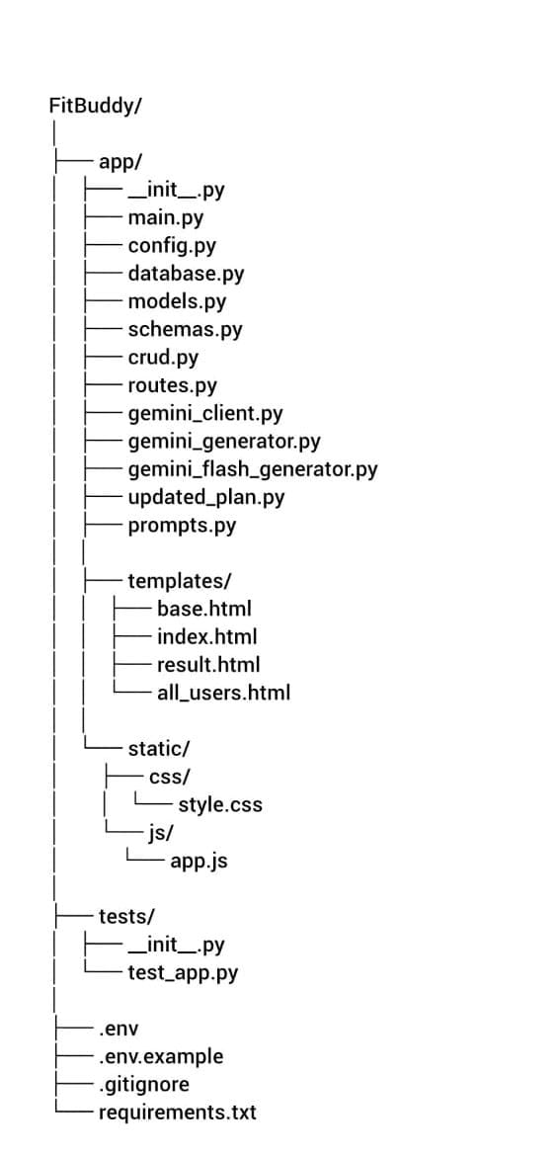

Milestone 2. Core functionalities Development
Activity 2.1 Develop the core functionalities:

Workout Plan Generation
Function: generate_workout_gemini()
File: gemini_generator.py
Implements the main logic for creating a customized 7-day workout plan based on user inputs such as fitness goal (e.g., muscle gain, weight loss) and workout intensity (low, medium, high). The prompt is passed to the Gemini 1.5 Pro model, which generates a structured day-by-day plan containing:

Warm-up (5–10 mins)
Main workout (exercise details, sets, reps)
Cooldown or recovery tip

The generated response is passed back to routes.py and displayed on the result.html page using <pre> blocks for proper formatting.
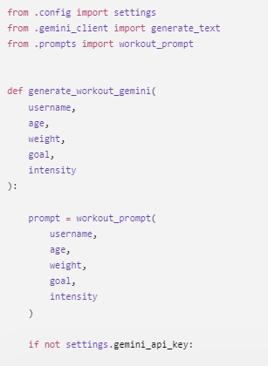

Nutrition Tip Generation
Function: generate_nutrition_tip_with_flash()
File: gemini_flash_generator.py

This function creates a short and useful nutrition or recovery tip based on the user’s chosen goal. It uses the Gemini Flash model to provide a quick and relevant response, such as hydration guidance, protein recommendations, or general recovery practices. The generated tip is shown below the workout plan in result.html
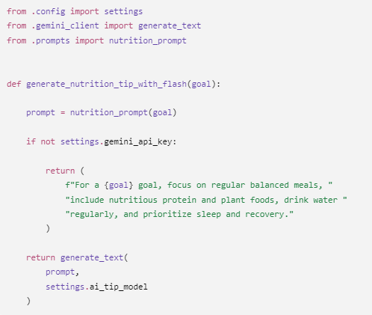

Feedback-Based Plan Updating
Function: update_workout_plan()
File: updated_plan.py
This function allows the user to modify their existing plan by providing feedback (e.g., "Add yoga", "Include more cardio"). The existing plan and feedback are sent to Gemini 1.5 Pro, which generates a revised plan incorporating the requested changes. The updated plan is then saved and shown together with the new nutrition tip.
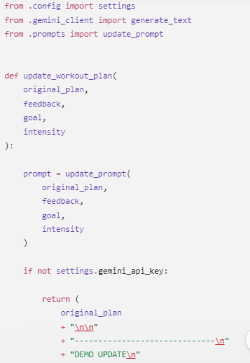
User & Plan Storage
Functions:
- save_user(), save_plan(), update_plan()
- get_original_plan(), get_user()
File: database.py
All user details (ID, name, age, weight, goal, intensity) and AI-generated workout plans are saved in a SQLite database using SQLAlchemy ORM. Feedback-based revisions are stored in a separate field to maintain both versions (original and updated).

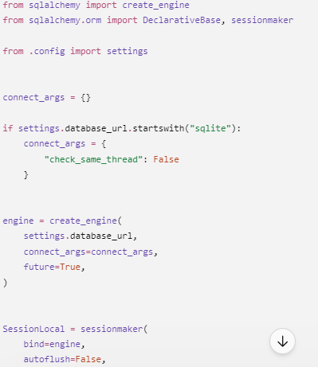

Admin View of All Users
Route: /view-all-users
Template: all_users.html
Shows a list of all users along with their respective plans. It is rendered using Jinja2 with a "{% for user in users %}" loop, allowing administrators to view the original and updated plans clearly in an organized table format.
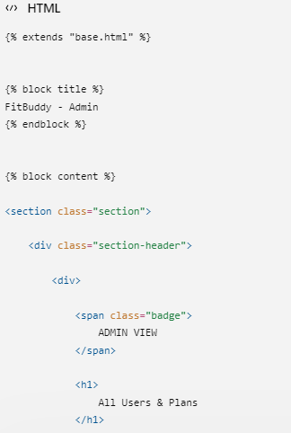

Activity 2.2: Implement the FastAPI Backend to Manage Routing and User Input Processing
All routing operations are managed in routes.py. Each route is connected to the appropriate function created in Activity 2.1.

Process User Input
- HTML Form: Designed in index.html
- Users provide: username, user_id, age, weight, goal, and intensity
- FastAPI receives the inputs through Form(...) parameters
- Pydantic schemas (UserInput, FeedbackRequest) are used to validate the input structure

Integrate Gemini API Calls
Each route handler is connected to the relevant Gemini-powered function:
- /generate-workout →
- generate_workout_gemini() for creating the workout plan
- generate_nutrition_tip_with_flash() for generating the tip
- /submit-feedback →
- Fetches the existing plan
- Passes the original plan + feedback to update_workout_plan()
All AI-generated outputs are returned properly and inserted into the frontend templates for display.

Milestone 3. routes.py Development

Milestone 3 concentrates on developing the routing logic within the routes.py file, which serves as the main operational layer of the FitBuddy application. It connects the frontend templates, AI generation modules (Gemini Pro and Flash), and the SQLite database. Each route specifies how user inputs are received, handled, and responded to — providing a dynamic and personalized experience for workout planning and feedback-based modifications.

Activity 3.1: Writing the Main Application Logic in routes.py

Defining Core routes in routes.py:
Individual routes were created to handle each of FitBuddy’s major functionalities:

- / : Shows the user form through index.html
- /generate-workout: Handles user input and creates a personalized workout plan
- /submit-feedback: Modifies the workout plan according to user feedback
- /view-all-users: Shows an admin dashboard containing all users and their plans

Set up Route Handlers for Each Feature

➤ / – Home Route
- Displays the homepage (index.html)
- Does not contain form processing logic

➤ /generate-workout – Plan Generator
- Accepts user input through FastAPI’s Form(...)
- Creates a UserInput Pydantic model
- Calls:
- generate_workout_gemini(...) → Creates workout plan using Gemini 1.5 Pro
- generate_nutrition_tip_with_flash(...) → Retrieves nutrition tip using Gemini Flash
- Stores:
- User details with save_user(...)
- Plan with save_plan(...)
- Returns result.html with dynamic information

➤ /submit-feedback – Update Plan with Feedback
- Receives feedback and user_id
- Fetches the original plan from the database
- Uses update_workout_plan(...) to modify the plan through Gemini 1.5 Pro
- Saves the revised plan in the database using update_plan(...)
- Displays the updated result on result.html

➤ /view-all-users – Admin View
- Uses get_all_users() and get_all_plans() to retrieve database records
- Sends the data to all_users.html

- Admin can view:
- Username, Age, Weight, Goal, Intensity
- Original and updated workout plans

Integrate Gemini AI Responses in Each Function
Each AI-related route communicates with Google’s Gemini models using specific prompts:
- Workout Plan Generation:
generate_workout_gemini() provides the fitness goal and intensity to Gemini Pro to generate a structured 7-day workout plan.
- Nutrition Tip Generation:
generate_nutrition_tip_with_flash() uses Gemini Flash to create a useful tip based on the user’s fitness goal.
- Workout Plan Update via Feedback:
update_workout_plan() sends the original plan and user feedback to Gemini Pro and produces a revised plan.
All generated responses are delivered to the user through result.html, with <pre> blocks used to maintain clear formatting.

Workout generation route Nutrition/Recovery tip generation route

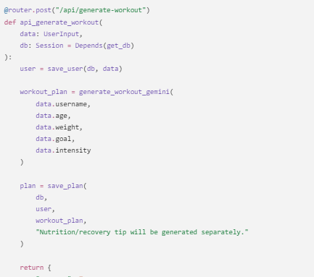

Nutrition/Recovery tip generation route
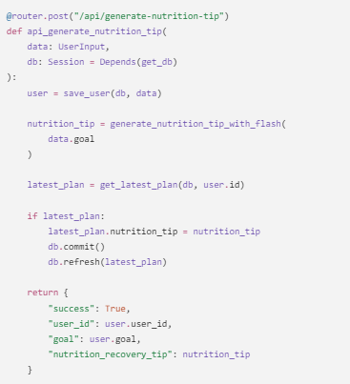
Saving user info and plan generation route
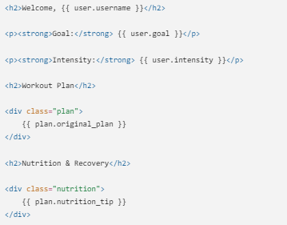
Submit Feedback and update plan route
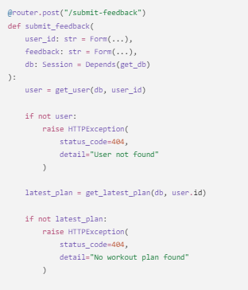

Milestone 4. Frontend Development

Milestone 4 concentrates on creating a user-friendly and visually organized interface for FitBuddy, the AI-powered workout generator. This includes developing responsive and interactive web pages using HTML, CSS, and Jinja2 templating. Each template is dynamically displayed through FastAPI, allowing users to easily enter their details, receive personalized workout plans, submit feedback, and enabling administrators to manage information efficiently. This milestone provides an engaging and easy-to-use fitness planning experience for all users.

Activity 4.1 Designing and Developing the User Interface

Set Up the Base HTML Structure

- Created index.html as the primary page for collecting user input.
- Organized the form to collect:
- username, user_id, age, weight, goal, and intensity.
- Each input field is clearly labeled and arranged using semantic HTML.
- The interface uses a gym-themed background image, Google Fonts (Roboto), and bold typography to provide a clean and fitness-focused design.
- Navigation remains simple to keep the user focused, while the flow clearly guides users from input to output.

Design a Responsive Layout Using CSS

- CSS styles were added directly within each HTML file.
- Layouts use Flexbox to align content vertically and horizontally.
- Media queries provide compatibility across mobile devices.
- Buttons follow uniform styling and include hover effects.
- Input fields and result sections include suitable padding, shadows, and rounded corners for a modern appearance.
- The overall color scheme improves readability against the dark background.

Create Separate Pages for Each Core Functionality

Three Jinja2-powered HTML templates were created under /templates:

- index.html: A user input form containing fields for fitness goal, intensity, and basic personal details.
- result.html: Shows the 7-day AI generated workout plan, nutrition tip, and provides an option for user feedback.
- all_users.html: Admin panel for viewing and deleting users and checking both original and updated plans.

Templates are organized into separate modules, and the interface moves smoothly between each step.
Forms are submitted to designated FastAPI endpoints using POST methods.

Activity 4.2 Creating Dynamic Templates with FastAPI’s Jinja2

- Integrate Jinja2 Templating for Dynamic Content Rendering

Implemented FastAPI’s Jinja2Templates for dynamic template display:
from fastapi.templating import Jinja2Templates
BASE_DIR = os.path.dirname(os.path.abspath(__file__))
TEMPLATE_DIR = os.path.join(BASE_DIR, "templates")
templates = Jinja2Templates(directory=TEMPLATE_DIR)

- Each route uses TemplateResponse to render the proper HTML with passed context:
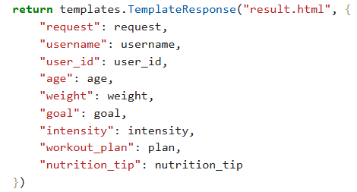
- This allows dynamic plan and nutrition tip display after form submission.

Bind Backend Data to HTML Templates

➤ index.html
- Form elements use name="..." to bind to backend Form(...) parameters.
- Submits data to /generate-workout.

➤ result.html
- Uses:
  - {{ username }}, {{ goal }}, {{ intensity }}, etc. to show user data.
  - {{ workout_plan }} and {{ nutrition_tip }} to show AI-generated results.
- Includes a feedback form submitted via POST to /submit-feedback.

➤ all_users.html
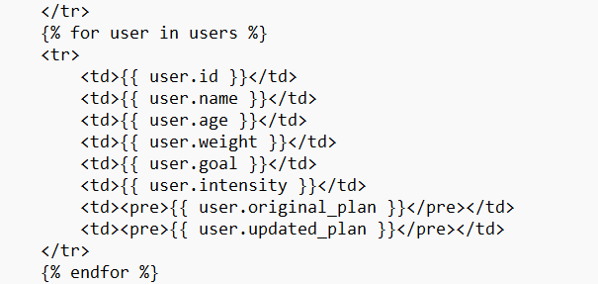
- Loops over all user records using:

Milestone 5. Deployment

At this stage, the focus is on running the FitBuddy application on a local system using FastAPI and Uvicorn. The application uses HTML templates with Jinja2 for rendering, along with Gemini-powered AI services. This milestone makes sure that all required environment dependencies are properly installed and that the application operates correctly on a local server, making it ready for future deployment on cloud platforms.

Activity 5.1: Preparing the Application for Local Deployment

Set up a virtual environment
- Create an isolated virtual environment to handle dependencies separately for the FitBuddy project.
- Activate the environment and install all required packages mentioned in the requirements.txt file, such as FastAPI, Uvicorn, SQLAlchemy, and Google Generative AI SDK. python -m venv venv source venv/bin/activate # On Windows: venv\Scripts\activate pip install -r requirements.txt

Configure environment variables
- Store sensitive information such as the Gemini API Key using environment variables.
- These values can be entered directly in the terminal or stored in a .env file and loaded into the application with python-dotenv.

GOOGLE_API_KEY=your_gemini_api_key_here

Frontend-Backend Rendering via Jinja2

User interactions are handled through Jinja2-rendered templates:

- index.html: Collects details entered by users
- result.html: Shows the AI-generated workout plan
- all_users.html: Displays all user records for admin view

Activity 5.2: Testing and Verifying Local Deployment
Access the Application Locally
The FastAPI development server is started using the command (uvicorn main:app —reload). After the server starts successfully, the application can be opened in any web browser by visiting http://127.0.0.1:8000. This URL opens the main user interface, where users can enter their details and create personalized fitness plans. The interactive API documentation available through FastAPI can also be accessed at http://127.0.0.1:8000/docs, enabling developers to view and test the available endpoints.

Exploring Website’s web pages:

Home page:
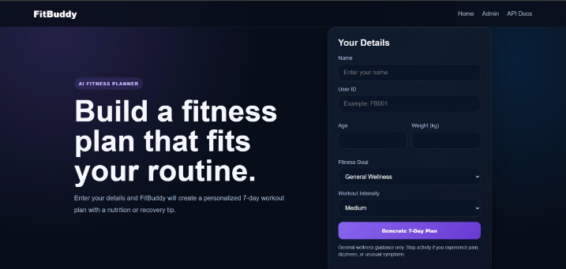

Description: The homepage of FitBuddy – AI Workout Generator features a clean and engaging user interface designed to provide a seamless experience for users seeking personalized fitness plans. The form prominently displayed in the center allows users to enter essential information including:
- Name
- User ID
- Age
- Weight (kg)
- Fitness Goal (e.g., weight loss, flexibility)
- Workout Intensity (Low, Medium, High)
After entering the required information, users can select the "Generate Plan" button, which activates the AI-powered backend to create a personalized workout and nutrition plan based on their goals and fitness details. The fitness-themed background image showing an active person enhances the overall visual design and supports the health-focused concept of the application.
This simple and user-friendly design allows users with different levels of experience to begin using the application easily and with minimal steps.
Personalized workout generation page:
User Information:
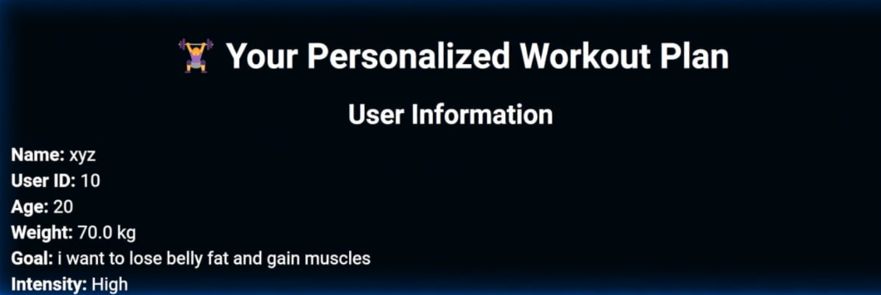
Description: Once the user submits their details, the application navigates to a personalized workout plan page. This section displays a summary of the user’s input including their Name, User ID, Age, Weight, Fitness Goal, and Selected Intensity. This personalized display ensures users feel acknowledged and guides the AI engine to generate relevant workout recommendations tailored specifically to their fitness journey.
Workout Plan: 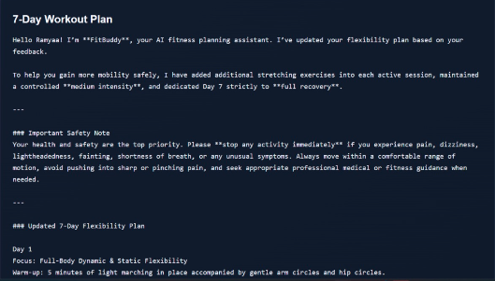

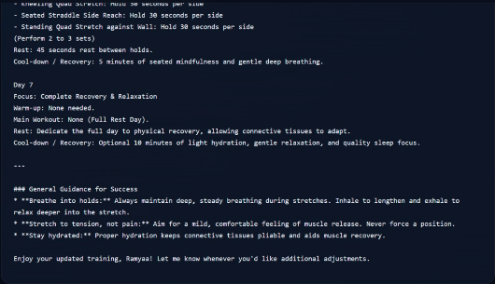
Description:
FitBuddy – AI-Powered Fitness Planning AssistantFitBuddy is an AI-powered fitness planning assistant designed to provide users with personalized and structured workout guidance according to their individual fitness goals, experience level, preferences, and feedback. The main purpose of FitBuddy is to make fitness planning easier by generating a customized 7-day workout schedule instead of providing the same routine to every user.The system collects relevant information from the user, such as their personal details, fitness objective, preferred workout intensity, and experience level. Based on these inputs, FitBuddy generates a day-by-day workout plan containing warm-up activities, main exercises, stretching routines, rest periods, and cool-down or recovery activities. The plan can be designed for different objectives such as improving flexibility, maintaining fitness, building strength, or supporting other general fitness goals.
Nutrition Tip:
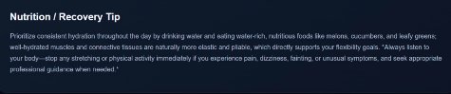
Description:
The Nutrition Tip section in FitBuddy provides users with concise, practical dietary advice to complement their workout plans. It emphasizes the importance of prioritizing protein intake in every meal, suggesting sources like chicken, fish, beans, or Greek yogurt. The tip explains how protein contributes to muscle building, satiety, and metabolic support—key factors for both fat loss and muscle gain. This section is designed to reinforce healthy eating habits that align with users’ fitness goals.
Feedback Page:
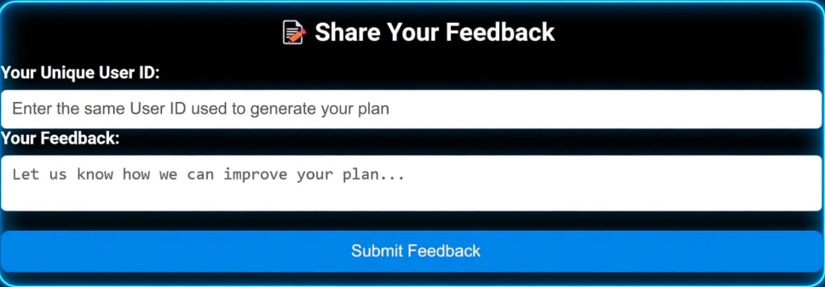
Description:
The “Share Your Feedback” section of the FitBuddy application allows users to provide feedback about their personalized workout plans. It contains a Unique User ID field where the user enters the same ID that was used to generate their workout plan. This helps the system identify the correct user and connect the feedback with their existing workout plan. The page also includes a Feedback text box where users can enter their suggestions, comments, or requirements regarding the generated plan. After entering the required information, the user can click the “Submit Feedback” button to send the feedback to the system. The submitted feedback can then be used to understand the user’s experience and identify changes that may be required in the existing workout plan. This feature supports the personalization process by allowing users to communicate their needs directly to the application. Based on the feedback received, the FitBuddy system can update or modify the workout recommendations to better match the user’s requirements. Overall, the feedback section provides an interactive communication between the user and the AI-based workout planning system and helps improve the personalization and usefulness of the generated fitness plans.
Once the plan is updated it comes with a confirmation message .


View all users page:
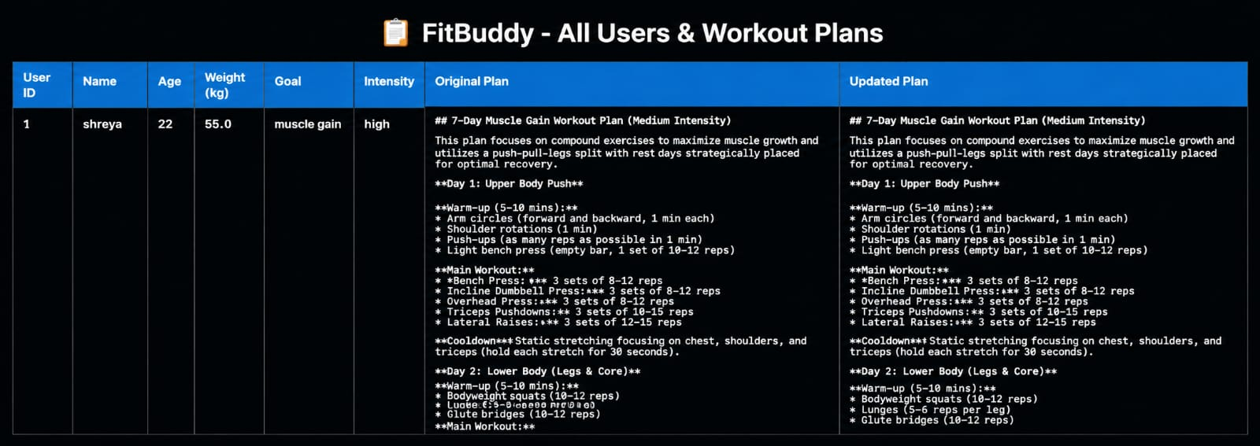
Description:
The “FitBuddy – All Users & Workout Plans” page provides an organized overview of users and their personalized workout plans generated by the FitBuddy application. It displays important user information such as User ID, Name, Age, Weight, Fitness Goal, and Workout Intensity in a structured table format. The page also contains two main sections, Original Plan and Updated Plan, which allow the system to display the workout plan initially generated for the user and the modified plan after considering the user’s feedback or requirements. In the example shown, the user Shreya, aged 22 and weighing 55.0 kg, has selected muscle gain as the fitness goal with high intensity. The generated plan includes different workout activities such as warm-up exercises, upper-body workouts, lower-body workouts, and cool-down activities. The updated plan provides modifications while maintaining the overall fitness objective. This feature demonstrates how FitBuddy can manage multiple users and maintain their personalized workout information in one place. By comparing the original and updated plans, users and administrators can easily understand how the workout recommendations have been adjusted based on individual requirements and feedback. Overall, this page demonstrates the application’s ability to organize user data, generate personalized workout plans, and update those plans dynamically to provide a more customized fitness experience.
Conclusion:
The FitBuddy – AI Fitness Plan Generator is a complete, user-focused web application that demonstrates the effective combination of artificial intelligence and health-tech solutions. Developed to support individuals in reaching their fitness goals, FitBuddy uses Google’s Gemini 1.5 Pro and Gemini Flash models to create personalized 7-day workout plans and daily nutrition or recovery tips based on user details such as age, weight, fitness goal, and preferred workout intensity.

The application is developed using the FastAPI framework for backend operations and API management, SQLAlchemy with SQLite for reliable data storage, and Jinja2 templating for a simple and responsive frontend. After entering their information on the homepage, users receive a customized workout plan containing warm-ups, main workouts, cooldowns, and goal-based tips. A key feature of FitBuddy is its feedback functionality—users can share feedback about the effectiveness or difficulty of their existing plan, and the system automatically modifies the plan using generative AI, providing continuous personalization and engagement.

The application also provides an administrative view where registered users and their respective plans (original and updated) can be displayed in an organized format. This feature helps with monitoring, transparency, and further improvement, making FitBuddy useful for individual users as well as coaches or institutions managing multiple fitness profiles.

Overall, FitBuddy provides a scalable and flexible AI-powered solution that personalizes the fitness experience while adapting to the user’s progress and preferences. It demonstrates how modern technology can be incorporated into everyday wellness routines to encourage healthy, consistent, and goal-focused lifestyles.

